Industrial AI-Based Demand Forecasting & Enterprise Decision Intelligence System

1. Introduction
The “Industrial AI-Based Demand Forecasting & Enterprise Decision Intelligence System” is an AI-driven analytics platform developed to support industrial forecasting, procurement optimization, and enterprise decision-making using machine learning and data analytics techniques.
The project aims to create a generalized and scalable system capable of processing industrial datasets in CSV/XLSX formats and generating intelligent business insights through automated preprocessing, predictive modeling, visualization, and decision-support mechanisms.
The system combines demand forecasting, cost analysis, safety-risk analytics, and procurement intelligence into a single interactive dashboard environment.

2. Problem Statement
Industries often face challenges in:
Predicting future demand accurately
Managing procurement strategies
Balancing manufacturing cost and operational risk
Analyzing large-scale enterprise datasets
Making intelligent business decisions in real time
Traditional manual analysis methods are time-consuming and may lead to inefficient procurement planning, increased operational costs, inventory imbalance, and delayed decision-making.
The objective of this project is to develop an AI-powered decision-support system that automates forecasting and procurement intelligence using machine learning models and interactive enterprise analytics.

3. Objectives
The major objectives of the project are:
To develop a generalized demand forecasting system
To automate preprocessing and feature engineering
To integrate regression and classification models
To build an AI-driven procurement decision engine
To analyze cost and safety-risk factors
To generate enterprise KPIs and visual insights
To create an interactive dashboard for industrial analytics

4. System Architecture
The project is designed using a modular architecture consisting of multiple integrated layers:

4.1 Data Input Layer
The system accepts:
CSV files
XLSX files
Industrial datasets
The datasets may contain:
Historical demand
Manufacturing cost
Logistics cost
Inventory metrics
Supplier data
Safety-risk indicators
Operational KPIs

4.2 Preprocessing Layer
The preprocessing pipeline performs:
Missing value handling
Duplicate removal
Outlier treatment
Feature encoding
Feature scaling
Temporal feature engineering
Automatic schema detection
The preprocessing layer ensures that datasets become suitable for machine learning workflows.

4.3 Feature Engineering Layer
This layer generates:
Derived enterprise features
Demand intelligence metrics
Cost optimization features
Operational efficiency indicators
KPI-based analytical features
The goal is to improve model performance and decision intelligence.

4.4 Machine Learning Layer
The system supports both:
Regression models
Classification models

Regression Models
Used for:
Demand forecasting
Cost prediction
Numerical trend analysis
Implemented models:
Linear Regression
Random Forest Regressor
Gradient Boosting Regressor

Classification Models
Used for:
Risk classification
Procurement categorization
Operational intelligence
Implemented models:
Logistic Regression
Random Forest Classifier
Gradient Boosting Classifier

4.5 Model Evaluation Layer
The models are evaluated using standard metrics.

Regression Metrics
MAE
MSE
RMSE
R² Score

Classification Metrics
Accuracy
Precision
Recall
F1 Score
The system automatically selects the best-performing model.

4.6 Procurement Decision Engine
One of the major components of the project is the AI-driven procurement decision engine.
The decision engine analyzes:
Predicted demand
Manufacturing cost
Safety risk
Operational constraints
Based on these factors, the system recommends:
Manufacture In-House
or
Procure Externally
The engine also generates:
Confidence scores
Procurement insights
Risk explanations

5. Dashboard & Visualization System
The project includes an interactive Streamlit dashboard integrated with Plotly visualizations.

Visual Components
Correlation Heatmaps
Actual vs Predicted Graphs
Residual Analysis
Feature Importance Charts
Confusion Matrices
Procurement Decision Pie Charts
Confidence Distribution Graphs
Trend Analytics
The dashboard enables users to interactively upload datasets, train models, analyze results, and monitor enterprise KPIs.

Flowchart/Data Flow
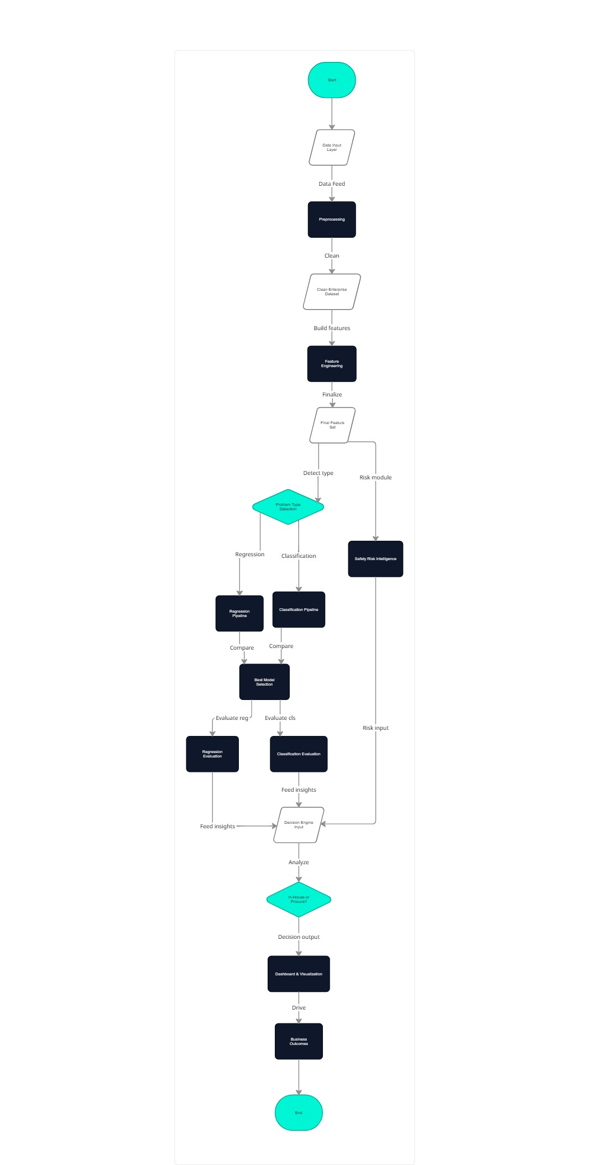

7. Technologies Used
The project was developed using the following technologies:

Programming Language
Python

Libraries & Frameworks
Pandas
NumPy
Scikit-learn
Plotly
Streamlit

Machine Learning Techniques
Regression
Classification
Feature Engineering
Model Evaluation

8. Project Workflow
The complete project workflow is:
Dataset Upload
Data Cleaning & Preprocessing
Feature Engineering
Automatic Problem-Type Detection
Model Training
Model Evaluation
Forecast Generation
Procurement Decision Intelligence
Dashboard Visualization
Enterprise Insights & Recommendations

9. Challenges Faced
Several technical challenges were encountered during development:
Integration of multiple modules
Import dependency conflicts
Visualization compatibility issues
Handling generalized datasets
Managing preprocessing pipelines
Model orchestration complexity
Streamlit dashboard integration
Feature engineering consistency
Procurement decision integration
These challenges provided practical exposure to enterprise-level AI system development and software integration workflows.

10. Learning Outcomes
Through this project, the following concepts were learned and implemented:
Industrial AI workflows
Enterprise analytics
Machine learning pipelines
Data preprocessing techniques
Feature engineering
Predictive analytics
Dashboard development
Procurement optimization
Decision-support systems
Software architecture design
System integration and debugging

11. Applications
The project can be applied in:
Manufacturing industries
Supply-chain management
Inventory optimization
Procurement analytics
Logistics planning
Enterprise decision-support systems

12. Future Enhancements
Possible future improvements include:
Deep learning integration
Real-time IoT analytics
Cloud deployment
Real-time forecasting APIs
Multi-user enterprise dashboard
Advanced optimization algorithms
Explainable AI integration
Predictive maintenance analytics

13. Conclusion
The “Industrial AI-Based Demand Forecasting & Enterprise Decision Intelligence System” successfully demonstrates how AI and machine learning can be integrated into industrial workflows for forecasting, procurement optimization, and enterprise analytics.
The project evolved from a simple forecasting model into a modular AI-powered decision-support platform capable of handling generalized industrial datasets and generating actionable business insights.
The system combines predictive analytics, enterprise visualization, and intelligent procurement recommendations into a unified interactive dashboard, making it a scalable foundation for future industrial AI applications.

